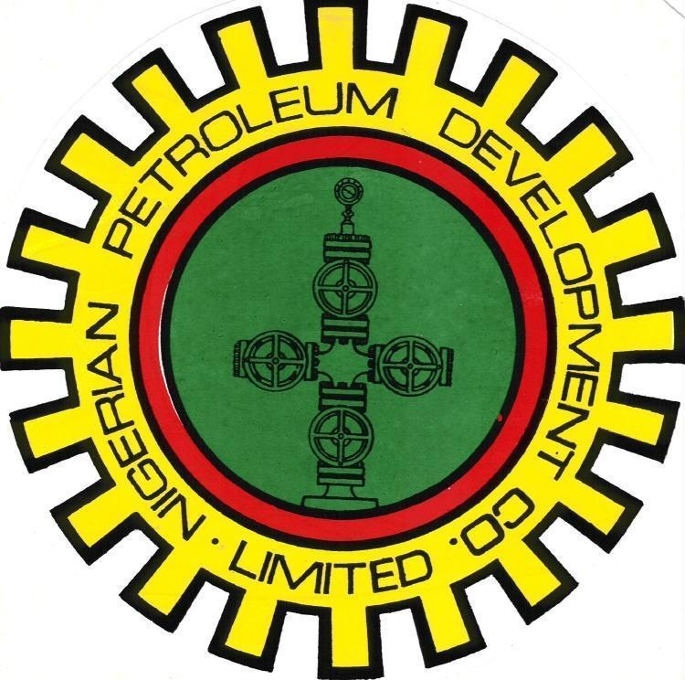
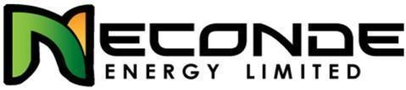

NECONDE ENERGY LIMITED

ODIDI 24L

DRAFT CT/SOLVENT DEWAXING PROGRAM

OML 42

JUNE - 2015

APPROVALS

ACTION | NAME | TITLE | SIGNATURE | DATE
Prepared by | Oludewa Awani
Reviewed by
Agreed by

Approved by

OBJECTIVE:
- Solvent dewaxing of production tubing and N2-lift well back to production.

COST & DURATION SUMMARY:
Total Cost (MM$) | 212,660.00
Total Duration (Days) | 2
N.B: Cost is based on CT & WL activity daily spread.

BASIC COMPLETION DATA:
WELL | Tree  type | Tree Connection | Tubing  Size | SCSSV  Size/type | ScSSSV  Depth | Last survey/well entry
Odidi-24L | Cooper Cameron FC | 3-1/2’’ ACME | 3-1/2’’ | 3’’ WL-ScSSSV | 153ftah | May-2015: ScSSV installation aborted due to suspected wax at 128ft/150ft. Wax was observed on GC ex-drift run to 128ft. RIH with scratcher and got stucked at tubing hanger. A 2nd GC run to 150ft observed thick-wax after POOH.

NB:
- Ensure well site visit is carried out to confirm X-mas tree adaptor prior to mobilization
- Conduct a well-slot visit to ensure that the well-slot is accessible for CTU operation before mobilization of CTU to site.
- Ensure completion of FLM and SLM works on wellhead, before commencement of CTU operation.

PRODUCTION DATA & WELL STATUS:
Test Date | Gross bbl/d | Net Oil bopd | BSW % | GOR scf/bbl | THP psig | Bean | Present Well Status
14/12/2014 | 2307 | 2295 | 0.5 | 179 | 334 | 24 | Well is CI for wax.

DFE to top CHH: 38.50ft
SAND: G8.0W
Known well problem: Interval is prone to wax
Refer appendix B for well completion schematics

ROLES & RESPONSIBILITIES:
Field Engineer:
The Field Engineer is in charge of the job at the location. He should hold pre-job safety briefing and job safety analysis (JSA), issue all safety permits and has overall responsibility for all safety matters during the operation. He should submit daily progress report to the line-manager/Supervisor.
Production Supervisor:
Operate (or assign an operator to operate) the wellhead control units and tree valves at the request of the Field Engineer. He should provide directives based on standard procedure at the wellhead and or flow-station.
Production Operators:
Responsible for wellhead operations, opening and closing of wellhead valves.
CT/WL Contractor
Supply certified CT/WL crew, certified CT/WL equipments, tools and perform operations in a safe and professional manner.
CT/WL Operator
Run CT unit, auxiliary equipment and perform operations as required, in a safe manner.
To submit a detailed report at end of exercise
NB: Invoice to be submitted along with the comprehensive CT/WL summary reports.

GENERAL OPERATIONAL SAFETY PRECAUTIONS
- The WI Field Engineer has the single point responsibility for this job and will communicate role description prior to the job for proper supervision.
- Before any work commence, the correct work permit will be completed in accordance with permit to work procedures.
- Security evaluation and assessment of area should be reviewed regularly and updates and/or changes are to be communicated to the WI field engineer and security team
- Pre-mobilisation equipment audit to be undertaken by WI Engineers & Supervisors ensuring that all pressure equipment (chicksans, Xmas tree adapters, wireline lubricator assemblies, BOPs etc) have valid test certification and test bands indicating ID, equipment numbers, current test dates and test pressures. Only equipment audited should be used on location.
- Daily tool box talk /Safety meeting to be held on site prior to commencement of job. The toolbox talk is expected to achieve the following; Job Objectives, Work Plan & Methods, Roles & Responsibilities, Access & Evacuation, Hazards, Controls & Contingencies, Equipment & Materials, Conflicting Activities.
- Standard oilfield safety practices for well intervention operations to apply.
- Only 1502 Weco Chicksans are to be used for hook-up on all pumping lines.
- All pressure tests are to be done for a minimum duration of 15 minutes.
- All equipment to be positioned at least 50ft away from the wellhead in line with hazard area classification for this operation.
- All equipment on location MUST be fitted with spark arrestor.
- Material Safety Data Sheet (MSDS) or SHOC cards of all chemicals to be used for this operation must be made available on site and accessible to the work-crew
- Carry out fire / man-overboard and medical evacuation drills to be conducted during the operation and such drill must be documented
- Barriers and Warning signs/notices shall be erected instructing all non-essential personnel to stay clear of the area.
- Gas monitors shall be available and gas testing carried out around the wellhead area before commencement of work and at (1 hour) intervals and result recorded accordingly.
- Functional eye shower and eye wash bottles MUST be available on site and located close to the treatment mixing area.
- Radio headsets will be utilised so that proper communication is maintained during the job.

GENERAL CT, WL & N2 SAFETY GUIDELINES
- All personnel involved in the CT operation will be aware of the details of the operation, the related safety points and the areas of responsibility as outlined by the WI Engineer in the pre-job meeting.
- Personnel will wear, at all times, the appropriate Personal Protective Equipment (PPE) as suited for this operation. The N2 Operator Must use cryogenic type hand gloves during the handling of N2 lines & hoses.
- Fire extinguishers will be available and located at a central access point during the CT operation.
- During the N2 Lift operation, the work area will be designated as a hazardous area and barricaded from general access. All non-essential personnel would be informed to stay clear of the area.
- Safety harnesses must be worn when working on top of the reel, injector head or at any unsupported height above two metres where safety may be at risk.
- Clamps must be used at all times to hold the tubing other than when it is stabbed in the injector head and in operation.
- Prior to the N2 Lift activity, the CT well control equipment must be function tested and pressure tested in accordance with standard Pressure Test Procedures.
- Treating lines must be secured with cable slings to fixed points at the opposing ends.
- Any treating lines must include a pressure relief valve (PRV) on the discharge side of the line. The discharge vent of the PRV should be positioned so that any discharged fluid or gas travels to an area remote of any personnel.
- When the CT is rigged up on the wellhead the CT Operator or a competent designated personnel must remain in the CT control cabin at all times.
- Other than when stabbing the coiled tubing into the injector head, personnel must NOT work on top or around the CT injector head while the hydraulic circuits are activated or power pack is running.
- While the coiled tubing is in the well, all valves in line with the wellbore should be secured in an open position by a fail-safe system. A responsible person to be assigned by the WI Engineer shall supervise the control system continuously during CT operations.
- While the CT is rigged up on the well, there will be no crane lifting operations above or in the vicinity of the CTU.
- Extreme caution to be used while handling and cutting coiled tubing. Due to the residual bend and stresses stored in the CT, it will have a tendency to spring when handled or cut. This situation will be amplified greatly if the tubing breaks or is cut while under pressure.
- When CT operations are suspended or completed, the well should be left in a safe condition and the site should also be left in a safe and tidy condition.
- The extremely low temperature of nitrogen (N2) in its liquid state can cause severe burns to the skin similar to that of a thermal burn. Cold nitrogen vapour can also have the same effect on delicate tissues such as those in the eyes. In its liquid form nitrogen can also cause structural damage to installations if spilt in sufficient quantities.
- Gaseous nitrogen is an asphyxiate and will displace air creating an oxygen deficient atmosphere within an enclosed area. Nitrogen vapour, when cold, is also heavier than air and will settle in low areas. Both of these factors can cause suffocation.
- Nitrogen is pumped under pressurised conditions, similar to other pressurised gas, its transfer must be carefully controlled and monitored due to stored potential energy.
- NO SMOKING rule MUST be strictly enforced.
- No environmental pollution.
- All work should be carried-out during daylight. Work should not progress under poor visibility or bad weather condition.
- Ensure the use of correctly sized tools and equipment during the job.
- Leaks should be avoided by ensuring that the lubricator and stuffing box are not leaking.
- Do not allow swab tank to fill and over-flow to avoid pollution of the area.
- Ensure all line and hoses between swab tank and well head are not leaking to avoid pollution.

EQUIPMENT REQUIRED
These may include, but not limited to the following;
- W/L unit / tools and surface equipment.
- Various sizes of gauge cutters (1.86’’, 2.3’’, 2.73’’ etc)
- CT unit, tools and equipment for solvent dewaxing and N2-lifting

FRONT-END ACTIVITIES
- Validate premob certificate of CT/WL equipment and tools.
- Ensure all safety and environmental precautions have been observed
- Check and confirm that production operation is fully aware of the intended operation
- Ensure Nitrogen lift operation is carried out when flowstation is up and functional.
- Confirm from production operations that the flow-line is hooked up and not leaking.
- Check and record well head pressures before commencement of job.
- Check wellhead for integrity, check and confirm the position of the valves, ensure xmas tree valves are closed, read and record CITHP, bleed off CITHP.
- Ensure flowback tank has a flame arrestor installed in the vent stack and all hoses and lines between the flow-back tank and wellhead are in good conditions and correct pressure rating.
- Ensure the CT is pull-tested to 15000ibs okay.
- Ensure the CT BHA is function tested okay.
- Ensure PT-1 & PT-2 are conducted on the CT, pressure control equipment and CT BHA before commencement of job.

WIRE-LINE ACTIVITIES
    - Check and confirm that the well is closed-in.
    - Record wellhead pressures (CITHP, CHP) using the provided template (if casing head pressure is high, bleed off, if it rises again, report to the office for instruction).
    - Rig up wire line BOP and lubricator on wellhead and pressure test to the CITHP for 15 minutes.
    - Hook up wing valve flow arm to the flow-back tank (environmental barge).
    - M/U 2.73” GC on WL toolstring, RIH to suspected wax HUD depth and POOH. Conduct an LIB run to confirm wax and wax HUD depth.
    - M/U 2.73’’ GC on WL and attempt to cut and flow the well. (Record pulling weight at every 500 ft to check for drag, if drag exceeds 500 lb, stop and review job with Field Engineer).
    - If wax–cutting is unsuccessful, POOH, R/D wireline and proceed to item -8 (solvent dewaxing)

COIL TUBING SOLVENT DEWAXING ACTIVITIES
    - R/U coil tubing and R/U coil tubing, ensure pressure tests 1 and 2 are performed, capture tests on chart.
    - Pickle CT and surface lines on the surface with 5 bbls 15% HCl and displace into the flowback tank. Neutralize acid in flow back tank with 15% caustic soda or 30% soda ash.
    - R/U coil tubing, RIH coil tubing/jet blaster nozzle, pump calculated volume of 40% xylene: 60% diesel mixture (bbls of xylene/diesel mixture required will be determined by wax- HUD depth and tubing I.D), allow to soak for 2hours minimum.
    - Wash wax with diesel (jetting mode), increase circulation to 1bpm and reduce RIH speed to dislodge wax.
    - Wash down to 11103ftah (mule-shoe depth) and POOH. Perform pull test every 500-1000ft. Circulate while POOH.

NITROGEN LIFTING ACTIVITIES
    - Line well to flowback tank and attempt to flow interval to production.
    - If interval is unable to flow, R/U and RIH CT at 10ft/min until clear of wellhead valves and other restrictions, thereafter increase to 20ft/min to below fluid level and commence lifting well with nitrogen at 250-300 scf/min (in stages of 500ft) to a maximum depth of 4000ft.
    - If at maximum lift depth of 4000ft below fluid level, a stable flow is not achieved, call office for advice before proceeding further down hole.
    - Nitrogen lift interval to production until FTHP stabilises. Pump Nitrogen at 250 – 300scf/min.
    - Gradually shut off nitrogen when flow stabilizes.
    - POOH CT. Monitor well performance at the flow-back tank, until flow is satisfactory.
    - POOH CT into injector head and close the XMT swab valve to isolate the injector head from the well flow. Continue to monitor the well.
    - Bleed off all pressures above the Swab valve.
    - Close the UMV and bleed off all pressures from the UMV to the Choke manifold. Close the flow line gate valve.
    - Bleed off all surface pressures and record total amount of returns received in flow back tank and effluent tank.
    - Rig down CT injector head and return line from the well
    - Pump all well effluent to the station by hooking up on the flowline at the wellhead.
    - Do not exceed a maximum pressure of 300 psi on the flow line. Inform the operations personnel of plan to pump effluent through the flow-line. Ensure the flowline is properly lined-up. Ensure the flow-line plug valve downstream the wellhead and the flow-line valve at the station are both opened.
    - Rig up wireline lubricator.
    - RIH and install WL-ScSSSV @ 150ftah and leak test as per standard procedure.
    - Open well on choke 24/64’’ to flowstation and record flowing pressures.
    - Rig down WL lubricator, clean up wellhead, hand-over well to production and demobilize

APPENDIX A: Wellhead Pressure Recording Template
Well Name: Odidi-24L
Initial Recording | On Arrival
Date: | Time:
CITHP (psig): | CHP (psig):
Final Recording | Before Departure
Date: | Time:
CITHP (psig): | CHP (psig):

APPENDIX B: Odidi-24 Completion Schematic

